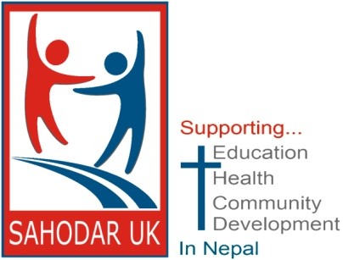
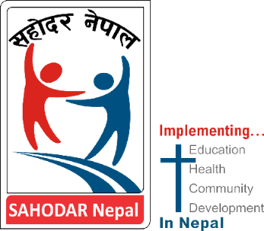

Reg. charity 1151639
It has been a long time since we have been able to bring you an update concerning the work of SAHODAR in Nepal, largely as a result of the COVID pandemic. Following the recent visit of two of our members, we are thrilled to be able to share wonderful news of developments with the hospital and Church.
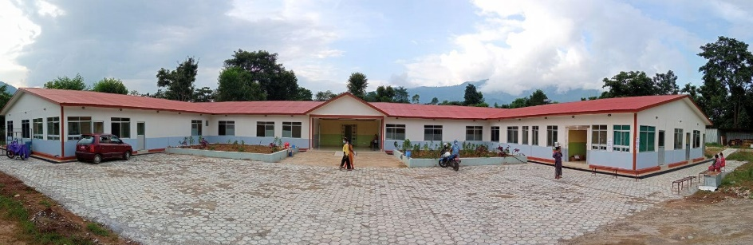
The Hospital
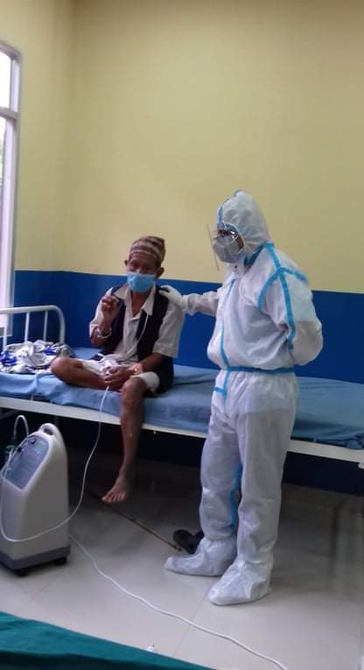
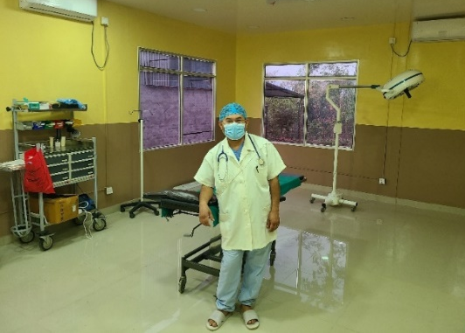
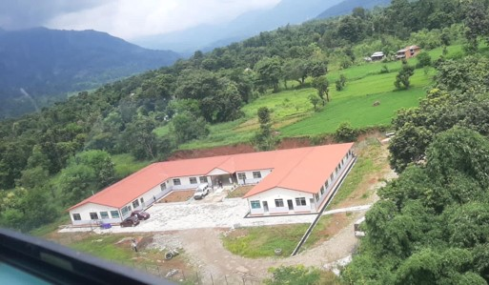
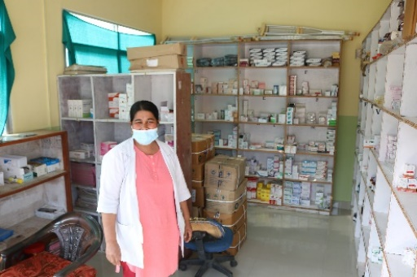
The long-awaited hospital is now open. A BIG THANK YOU to all of you who have helped to make this possible. For two years after the framework was constructed, it lay unfinished awaiting sufficient finance. Many of the staff of the previous cottage hospital would meet daily on site to pray for a resolution. Then, as a result of a generous gift of a UK benefactor and a miraculous, unprecedented government grant the hospital was completed in time to serve the community through the COVID pandemic. At that time, half the hospital was dedicated to treating COVID patients. Without this, it is likely that many would have died. A critical oxygen plant was built, enabling oxygen to be piped to the wards. The hospital and staff were highly commended by the local government for their significant contribution through this very challenging time. We are about to provide funds to replace a broken controller unit for the vital x-ray machine which has been beyond repair for the past two years. Also urgently needed, is a ceiling mounted operating light, a modern operating table and, of course, on-going staff salary support. As a ‘mission hospital’, apart from the one building grant received during COVID, it receives no government funding. Currently, the hospital is licenced for just 15 in-patients, which is about right for the current need. When staffing levels permit, it is hoped this will rise to 25, and eventually 50, with the provision for nurse training. Currently they serve 25-40 outpatients a day, but this will rise significantly during the monsoon season (June – August). Common ailments include chest complaints, enteric fever, stomach issues, injuries/fractures. The well-stocked pharmacy has a steady flow of visitors throughout the day. Regrettably, alcohol dependency affects the families of a significant number of the district population, including the population of Garambesi; something Dr Shiva and the local council are planning to try and address. The SAHODAR hospital is very highly regarded and valued by all in the community ... they are so thankful for its vital service.
The Church
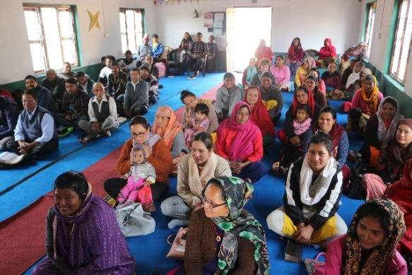
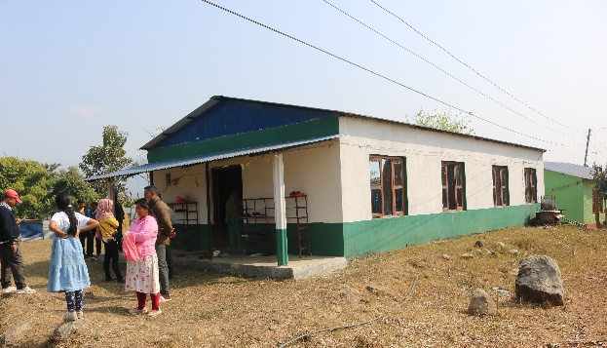
The new SAHODAR UK funded Church building which replaced the previous bamboo structures was opened only briefly in 2020, prior to the pandemic, but is now fully functioning as a place of worship and also as an occasional community meeting place. There are four ‘daughter’ churches meeting in homes further afield. The total membership is about 300. Currently there are severe restrictions on how the Church can share the Gospel. The communist government is actively trying to prevent the growth of the Church in Nepal, but, whilst making it difficult, the Church continues to grow.
Roger Aldersley
Some of you may not be aware that the true inspiration behind the work of SAHODAR UK, Roger Aldersley, went to be with the Lord last summer. Roger and his wife Jean, worked tirelessly in Nepal and at home, and were the driving force for establishing SAHODAR UK. The legacy of blessing they have created in this poor community is beyond measure. We and SAHODAR Nepal are so grateful for his love, inspiration, generosity and guidance.
Taste of Nepal
If you can, perhaps join us for some typical Nepali dhal and rice, followed by delicious English cake and refreshments, on Sat 13th May, at 6.30pm at Mutley Baptist Church (rear entrance). John and Beverly George will be speaking about their recent visit to Nepal. Please let Kate (kateandstevebrown@gmail.com) or John (treasurer@sahodaruk.org) know if you plan to come. If you are unable to come, but would like a copy of the PowerPoint presentation, simply let us know and we’ll gladly email a copy to you after the event.
Support needed
Please, if you are a believer, pray for us and our partners working hard in Nepal in service of those in need.
If you are able, consider contributing to the work:
- bank transfer to SAHODAR UK, sort code 56-00-63, account 38418940
- cheque payable to SAHODAR UK, sent to 8 Forder Heights, Plymouth, PL6 5PZ
- online : www.sahodaruk.org (We are well aware that the website is in need of updating! It is in hand)
Perhaps consider joining those who make a monthly standing order donation. Thank you. Every pound we receive is given to the work in Nepal. We take no administration costs.
Contacts
Through the website www.sahodaruk.org or www.facebook.com/sahodaruk
Email: treasurer@sahodaruk.org

